**SWOT analysis template**

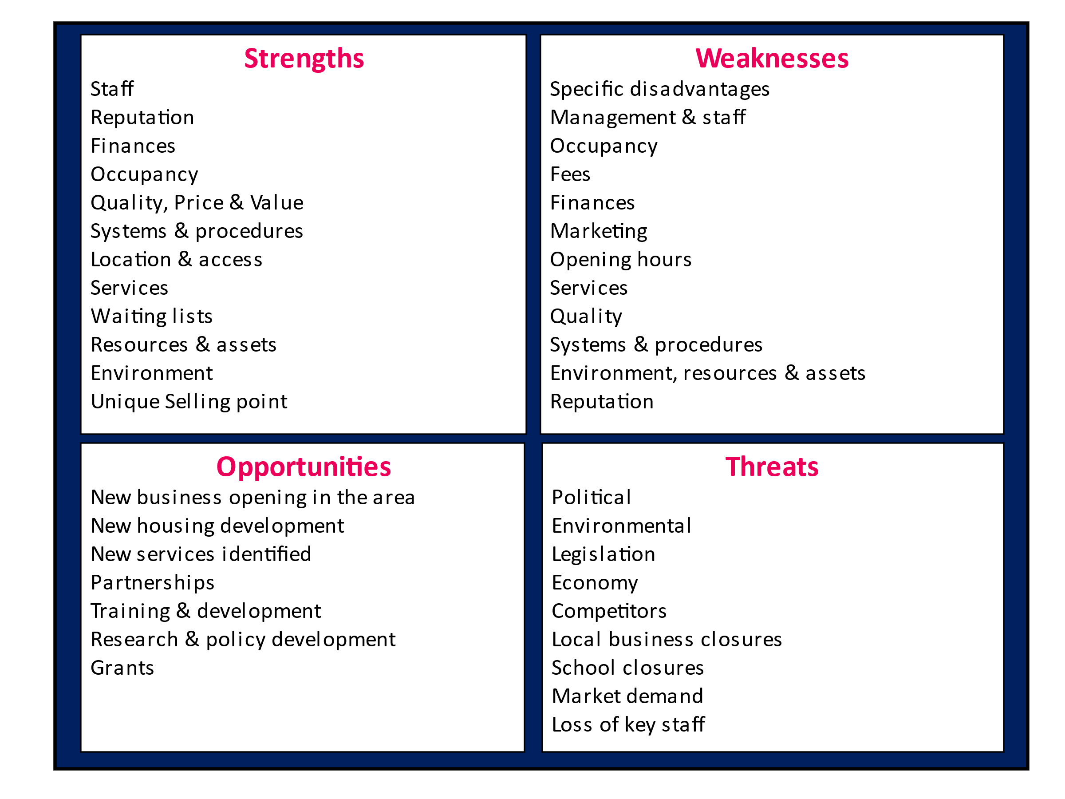

|  |  |
| --- | --- |
| Strengths | Weaknesses |
|  |  |
| Opportunities | **Threats** |
|  |  |